Determination of Cement Quantity for Standard Grades of Concrete

MoRTH Data Book – Approach & Conditions for Preparation of Standard Data Book
- Clause 7.1: Quantities of materials considered in the rate analysis are approximate for the purpose of estimation and include normal wastage. Actual consumption of material quantities are based on mix design
- Clause 10.21: 10% extra cement may be provided for concreting under water, where required
- Clause 10.23: Quantities of cement in various grades have been taken as per IRC:112 and Clause 1703.3 of MoRTH specifications

MoRTH Specifications
- Clause 1703.2: Minimum grade of concrete, minimum cement content, and maximum W/C ratio are based on exposure condition specified in Table 1700-2 for normal concrete and in Table 1700-3 for Sulphate Attacked concrete (Note-ii: Cement Content includes all cementitious materials)

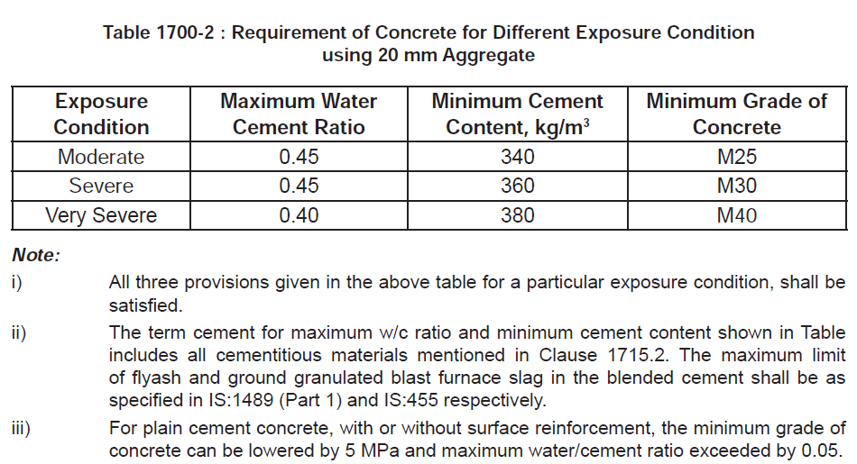
Cement content shown in the above table shall be increased by 40 kg/m3 for use of 12.50 m nominal size aggregates and decreased by 30 kg/m3 for use of 40 mm nominal size aggregates.
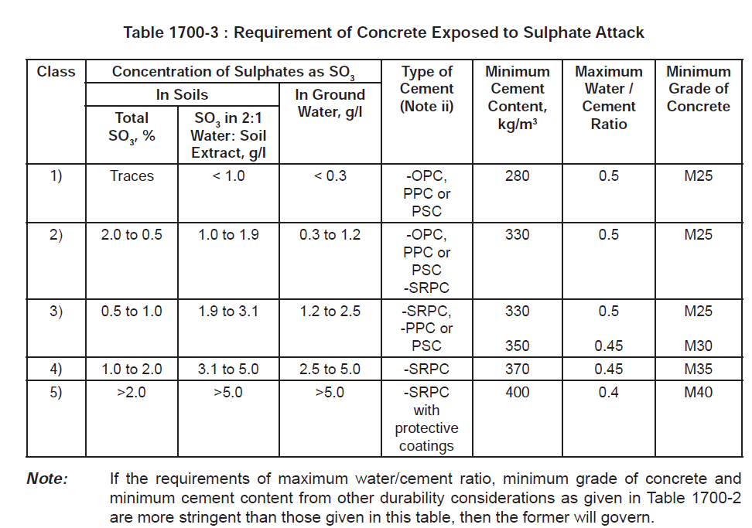
OPC: Ordinary Portland Cement; PPC: Portland Pozzolona Cement; PSC: Portland Slag Cement; SRPC: Sulphate Resisting Portland Cement
The Maximum Cement Content, excluding any mineral admixtures (i.e. portland cement component alone), shall not exceed 450 kg/cum

IRC: 112 (Code for Concrete Road Bridges)
- Clause14.3.2.1: Concrete mix proportions and cover
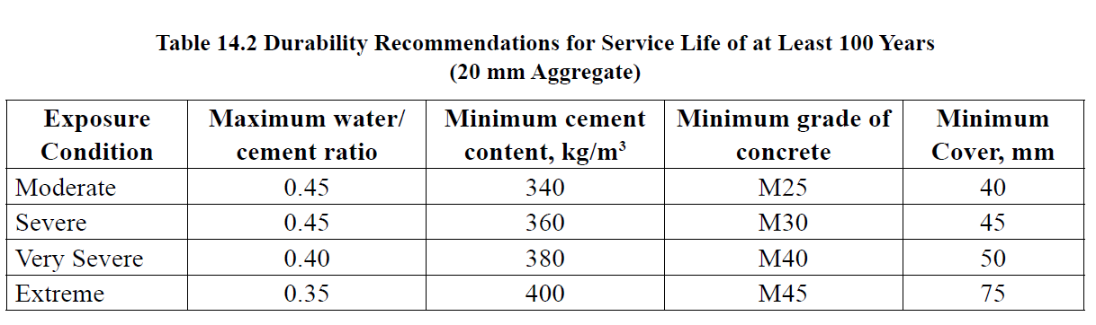
  - All four recommendations given in the Table for a particular exposure condition, shall be satisfied.
  - For post tensioned tendons, the minimum clear cover measured from the outside of the sheathing shall be 75 mm.
  - For pre-tensioned tendons, minimum cover shall be 65 mm.
  - Minimum cover shown in Table 14.2 can be reduced by 5 mm in case of factory made precast concrete elements, high performance concrete, use of stainless steel reinforcement, or controlled permeability formwork (refer Clause 14.4.1). In case more than one of the above measures are adopted the reduction should not exceed 10 mm.
  - The term cement for maximum w/c ratio and minimum cement content in Table 14.2 includes all cementitious materials inclusive of additions mentioned in Clause 18.4.
  - For plain cement concrete, with or without surface reinforcement, the minimum grade of concrete can be lowered by 5 MPa and maximum water/cement ratio exceeded by 0.05.
  - For all foundations and elements below ground level minimum cover shall be 75 mm.
  - For design service life of 50 years or less, the minimum cover can be reduced by 5 mm.
- Clause 14.3.2.2: Adjustments for other aggregate sizes
For aggregate sizes other than 20 mm, the minimum cement content shown in Table 14.2 shall be adjusted as per Table 14.3.

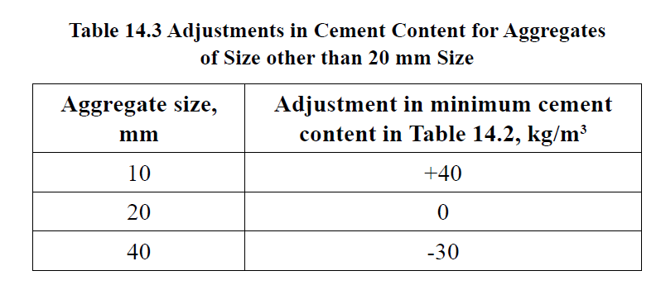
- Clause 14.3.2.5: Maximum cement content: Cement content (excluding fly ash, GGBS or Silica Fume) shall not exceed 450 kg/m3
- Clause 14.4.2: Sulphate attack & Table 14.4 : Same as given in the MoRTH specifications

Concrete Mix Design shall be done as per IS: 10262 and relevant provisions of MoRTH Specifications/IRC:112

Abstract of Minimum Cement Quantities for Various Exposure Conditions based on different references

Type of Concrete | Minimum Grade | Minimum Cement Content (kg/cum)/W-C Ratio |  |  |  | MoRTH Data
Type of Concrete | Minimum Grade | IS: 456 | IRC:112 | MoRTH Specs | IRC: 122  (Precast) | MoRTH Data
Nominal Mix | DLC |  |  |  |  | 150
Nominal Mix | 1:3:6 |  |  |  |  | 230
PCC | < M15 | 220
PCC | M15 | 240 |  |  |  | 275
PCC | M20 | 250 |  |  |  | 344
PCC | M20 | 260 |  |  |  | 344
PCC | M25 | 280 |  |  |  | 400
PCC | M30 |  |  |  |  | 405
PCC | M35 |  |  |  |  | 419
RCC | M20 | 300 |  |  |  | 347
RCC | M25 | 300 | 340 | 340 | 340 | 403
RCC | M30 | 320 | 360 | 360 | 360 | 407
RCC | M35 | 340 |  |  |  | 422
RCC | M40 | 360 | 380 | 380 | 380 | 430
RCC | M45 |  | 400 |  | 400 | 430
RCC | M50 |  |  |  |  | 430
RCC | M55 |  |  |  |  | 440
RCC | M60 |  |  |  |  | 445
RCC | M65 |  |  |  |  | 450
PQC | M35 |  |  |  |  | 400

Exposure Legend
Extreme
Very Severe
Severe
Moderate
Mild

Maximum Cement Content: 450 kg/cum (Clause 8.2.4.2 of IS:456; Clause 14.3.2.5 of IRC:112 and Clause 1703.2 of MoRTH Specifications)

